create boot image

ADK is the prerequisite

with SCCM version, may need to upgrade boot image(if new hardware)

n/w and storage drivers are must

winpe from vendor site

run adk (Deployment and imaging tools environment) as admin on SCCM server

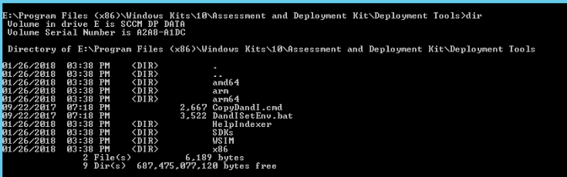

Run copype command and get the wim file from media folder created by this

**copype amd64 C:\ E:\Sources\OSD\Boot\<FolderName>**

Create a boot image, under boot images

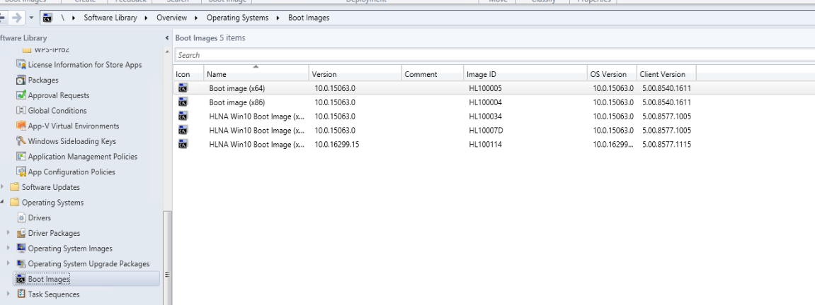Right click and add boot image

Point Source path to wim file

e.g

\\HLNASVR3021\Sources$\OSD\Boot\Win10_Boot_v2.0\boot\boot.wim

After that download WINPE from vendor site (depends on the hardware manufacturer)

Copy winpe to Sources$\OSD\Driversources\dell winpe10

Import drivers from the winpe using the import driver wizard under Driver Packages>WinPE right click and import and point to winpe folder where we copied, it will also create driver package.

it will prompt u if u want to inject them to boot image, will show only image where these can be injected

Create a driver package from the winpe extract create in above step

Create a WIM file using work bench before you deploy and capture

Create deployment share

Copy the iso to sccm server

Extract the ISO

Import the extracted content from DP share under operating system

Check move to DP folder, it will save to deployment share rather than having 2 copies of same data

Select full set

Give the path of extract folder

Will create a wim file for all indexes

Create task sequence under work bench deployment share

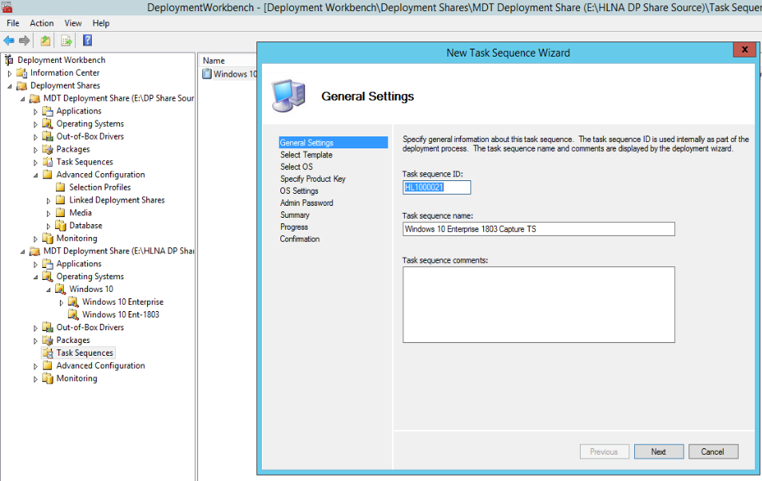

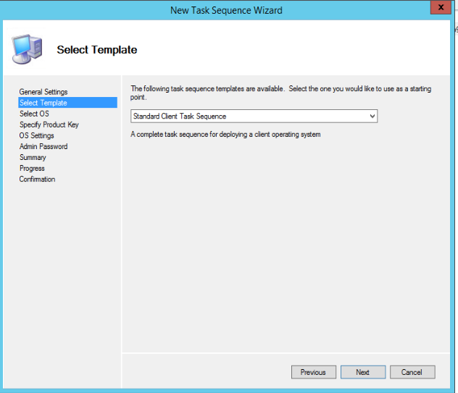

Use wim file

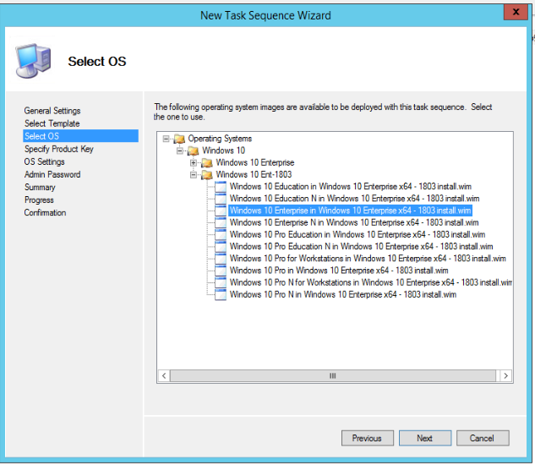

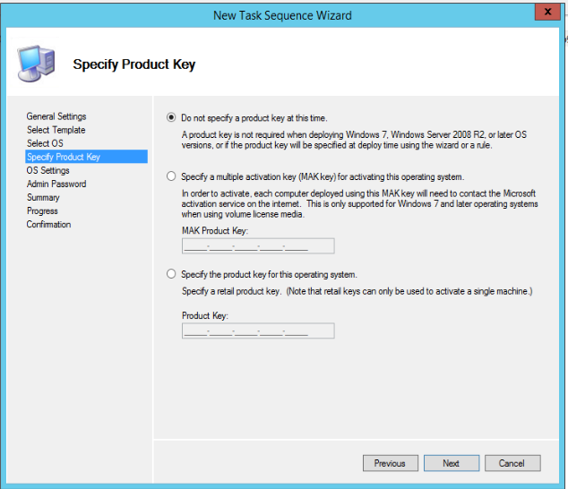

Full name in this case OSL Admin

Organization OneSolution Logistics

Home page: home page of the organization

On the TS Customize as needed, like add software’s, features

Go to deployment share properties and customize rules as needed

Add features to wim

Edit bootstrap INI

Update the deployment share

Completely generate

Will create folders under deployment share\boot

Copy the ISO generate by above step

Boot a vm from the iso created above

Select ts created in deployment share

Capture the image and name it

ISO's are on Hlnalun3176005 datastore

Hlna

Deployment- ts are for upgrade

Imaging - ts are for reimaging a system

Task sequence:

MDT task sequence (available only if you have ADK installed on SCCM server)

Create MDT task sequence

Build and capture a reference OS

Name it, select the boot image